**INTRODUCTION TO SQL SERVER**

**SQL SERVER:** SQL Server is an RDBMS product which was designed and

developed by Microsoft Company.

SQL Server will provide Graphical User Interface (GUI) facilities it means that

user can interact with the database using icons without remember any commands.

SQL Server will run only windows operating system i.e. it is a platform dependent.

The first version of SQL SERVER is 1.0 was released in 1989 and up to now 11.0

versions are available. Those are…

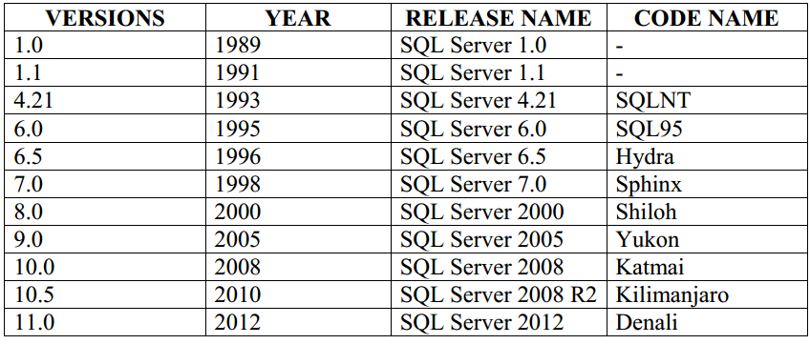

**Working with SQL SERVER:**

SQL Server is a collection of databases where database is a collection of various objects like Tables, Views, Procedures and Functions etc.

To work on SQL Server we use SQL Server Management Studio. It is a tool used

for the SQL server. If we connect to server it shows a window with ….

* Server Type
* Server Name
* Server Authentication
* Username & Password

**Server Type:** SQL server contains five types of servers those are

* **Database Engine:** The Database Engine is the core service for storing,

processing, and securing data (or) it is used to store, manage and to access

the data from the database.

* + **Analysis Services:** It is used for data warehouse it will show the data in

three dimensions (Rows, Columns and New dimension).

* + **Reporting Services:** It is a reporting tool used to generate reports in

various formats such as creating interactive, tabular, graphical,

multidimensional, or XML-based data sources. Reports can include rich data

visualization, including charts, maps etc.

* + **Integration Services:** It is used to convert tables from relational database

To another relational database for e.g. If we want to convert SQL Server

tables to ORACLE tables or My SQL tables then will be used.

* + **SQL Server Compact Edition:** It is used to develop mobile application

or mobile software.

**Server Authentication:**

We have two types of authentications are

**Windows Authentication:** Windows Authentication work on the user

admin and when we work on window authentication there is no required user name

and password because operating system will generate User Id and Password by

default.

**SQL Server Authentication:** SQL Server will work on the current user

and when we work on SQL Server authentication then user should enter User Id

and Password (These User ID and Password will give at the time of SQL Server

installation).

**Step To Connect To SQL SERVER:**

Go to start -> Go to programs -> Go to Microsoft SQL Server 2008 R2/12 -> Click on

SQL server management studio -> Click on connect button.

**Object Explorer Window:** This window contain Database, Security, Server

Objects, Replication and Management options.

**SQL Server contains two types of databases these are**

* + **System Database:** The system database include the following four

databases

* + **Master:** It is used to manage system level information of SQL server.
  + **Model:** It is used as a template for all new creating databases in SQL

Server.

* **Msdb:** It is used to store the alerts and job information contains the

SQL commands which are executed by user.

* **Tempdb:** When ever SQL server is started tempdb will be created in

SQL server. It is used to store temporary tables once we restart the

server the tempdb database is destroyed.

* **User Database:** These databases are created and manage by the user for

storing their objects like tables, views, procedure etc.

**Steps to Create User Database:**

Go to open SQL server management studio => Click on Connect button to

connect server => Go to Object Explorer window => Select Database and click on

right mouse button => Click on new database option => Type database name in

database name textbox control => Click on Ok button

* Whenever we create a database on SQL Server, it will generate two

database files are

**Primary Data file:** It contain the start up information of the database and used

to store database objects like tables, views .This file will saved with an extension

.mdf(Master Data file).

**Log File:** This file contains transaction query information will saved with an

extension .Ldf (Log Data file).

**Root Location for .mdf and .Ldf files:**

C:\Program Files\Microsoft SQL

Server\MSSQL10.MSSQLSERVER\MSSQL\DATA

**Data Types in SQL Server:** A data type is an attribute that specifies what

types of data enter by the user such as integer, character, decimal, date time etc.

* Integer Data Types
* Decimal Data Types
* Money (or) Currency Data Types
* Date & Time Data Types
* Character Data Types
* Binary Data Types